**Pizza sales SQL queries**

Select all from table

select * from pizza_sales

1. KPI’s
2. Total Revenue generated.

select SUM (unit_price) as total_revenue from pizza_sales

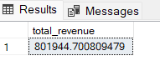

1. Average order value

select (SUM (total_price) / COUNT (DISTINCT order_id)) AS Avg_order_value FROM pizza_sales

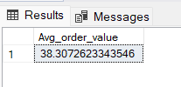

1. Total pizza sold

select SUM (quantity) AS Total_pizza_sold from pizza_sales

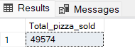

1. Total order

select COUNT (distinct order_id) as Total_order from pizza_sales

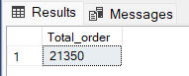

1. Average pizza per order

select CAST (SUM (quantity) AS DECIMAL (10,2)) / CAST (COUNT (DISTINCT order_id) AS DECIMAL (10,2)) AS avg_pizza_per_order from pizza_sales

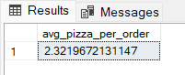

1. Daily trend for total order

SELECT DATENAME (DW, order_date) as order_day, COUNT (DISTINCT order_id) AS To tal_orders FROM pizza_sales

GROUP BY DATENAME (DW, order_date)

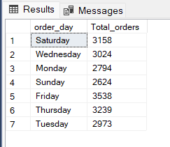

1. Hourly trend for total order

select DATEPART (HOUR, order_time) AS order_hour, COUNT (DISTINCT order_id) AS total_orders

from pizza_sales

GROUP BY DATEPART (HOUR, order_time)

ORDER BY DATEPART (HOUR, order_time)

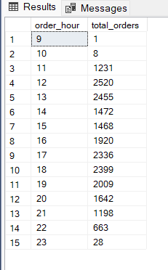

1. Percentage of sales per pizza categories

select pizza_category, SUM (total_price) * 100 / (select SUM (total_price) from pizza_sales)

from pizza_sales AS total_sales

GROUP BY pizza_category

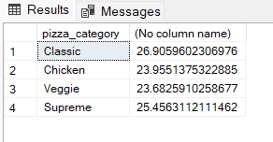

1. Total pizzas sold by pizza category

select pizza_category, SUM (quantity) as Total_pizza_sold

from pizza_sales

Group by pizza_category

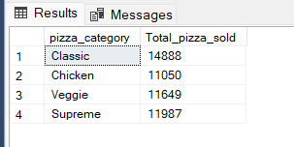

1. Top 5 best sellers by total pizza sold

select TOP 5 pizza_name, SUM (quantity) as Total_pizza_sold

from pizza_sales

GROUP BY pizza_name

ORDER BY SUM (quantity) DESC

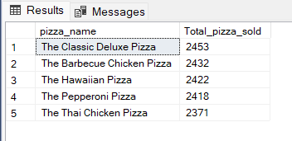

1. Bottom 5 worst sellers by total pizzas sold

select TOP 5 pizza_name, SUM(quantity) as Total_pizza_sold

from pizza_sales

GROUP BY pizza_name

ORDER BY SUM(quantity) ASC

